REPORT: Design of Harmful Algal Bloom Algorithms for CE-QUAL-W2.
Prepared for: USACE-ERDC-EL-WQB
Prepared by: LimnoTech
Contents
Overview 2
Code Enhancements 4
Vertical Migration (CE-1) 4
Nitrogen Fixation (CE-2) 6
Hypoxic Conditions (CE-3) 7
Minimum Algae Concentration (CE-4) 10
Treatment Regimes (CE-5) 11
Review for Relic Code (CE-6) 13
Documentation of Best Practices (BP 0-7) 15
Useful Tools (UT) 16
User Community (UC) 17
High-Resolution Dataset Linkage (HR 1-5) 18
Prioritized Implementation Roadmap 19
Next Steps 20
Appendix 1 – Watercourse W2 AVM Exploratory Analysis 21
Appendix 2 – Building a User Community 46

Overview
Task 1 (“Design of Harmful Algal Bloom algorithms for CE-QUAL-W2”) of Delivery Order W912HZ23F0178 (“Water Quality Model Development to Manage Harmful Algal Blooms”) under USACE-ERDC Contract No. W912HZ-20-D-0004 called for LimnoTech and Watercourse Engineering to develop conceptual models of HABs dynamics in Corps reservoirs.
This note outlines the design, describes the conceptual model(s), discusses algorithms, and provides prioritized direction for implementation of enhancements to W2.
Under Task 1 of Delivery Order W912HZ23F0288 LimnoTech identified the following needs:
- Code enhancements related to buoyancy, nitrogen cycling, and hypoxic conditions.
- Documentation of best practices for segmentation, etc.
- Identification, collection, and documentation of existing useful tools.
- Development of an effective and engaged developer and/or user community.
- Linkage to high-resolution datasets or models to superimpose heterogeneity on W2’s laterally-averaged results.
Discussions within the contract team identified some additional needs:
- Enhancements related to treatment regimes and minimum algal concentrations.
- Review of code for limitations hanging on from "original" implementation as BOD
The needs mapped to the following 21 opportunities for improvement in W2 capabilities with respect to HABs:
Each need is presented below with a brief discussion of importance, a conceptual model (where appropriate) and a qualitative assessment of the level of effort necessary for next steps.
The identified opportunities were then prioritized according to combined rankings from contractor and ERDC staff:
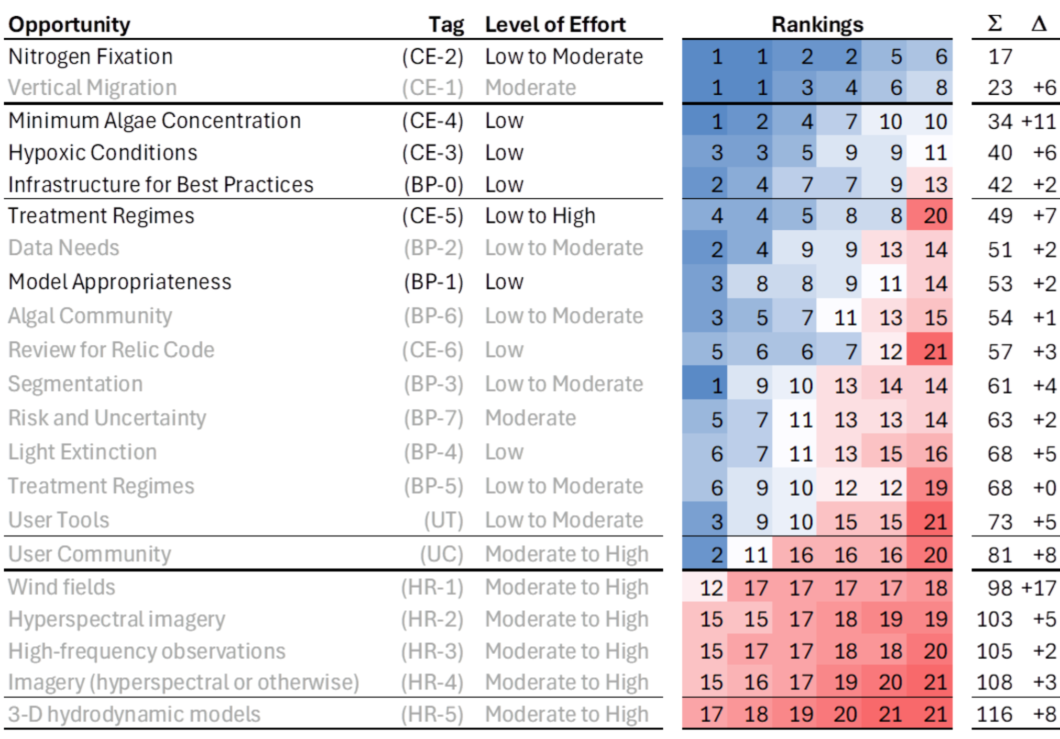
Six opportunities were initially suggested by contractor staff (CE-1 through CE-5, BP-0 and BP-1). Project Team review and discussion ended with the selection of four code enhancement opportunities for initial implementation:
- Minimum Algae Concentration (CE-4)
- Mechanical Removal (Treatment Regimes) (CE-5)
- Hypoxic Conditions (CE-3)
- Nitrogen Fixation (CE-2)

Code Enhancements
Six areas were identified as candidates for W2 code enhancement or review:
- Vertical Migration
- Nitrogen Fixation
- Hypoxic Conditions
- Minimum algae concentration group/species? [Mike to check with Zhong]
- Treatment Regimes
- Review for Relic Code

Vertical Migration (CE-1)
Importance. Cyanobacteria, frequent contributors in HABs occurrences, are well-known to have the ability to rise and sink within a diurnal cycle via buoyancy regulation. W2 has recently incorporated model logic to represent algal vertical migration related to buoyancy regulation. Four different algae vertical migration (AVM) models, termed “Continuum Model” under CE-QUAL-W2 terminology, were added:
- AVM 1 (settling velocity, which will be termed as “velocity” for the rest of this document, depends on time only),
- AVM 2 (velocity depends on time and space (a limit to vertical migration),
- AVM 3 and 4 (velocity depends on density growth, computationally intensive)
Watercourse Engineering has performed an exploratory analysis of using AVM 2 to assess algorithm effectiveness. An existing CE-QUAL-W2 model of a representative reservoir flow and water quality model was used as the basis for three model grids with varying vertical segmentation: Grid A with 1 m layer height, Grid B with 0.5 m layer height, and Grid C with 0.25 m layer height for the first 9 m and 0.5 m layer height below. Three runs (A, B, and C) were performed with the respective grid and AVM 2 used, and a fourth run (D) was performed with no AVM.
Some key findings:
- Grid resolution has an impact on simulated vertical distribution of cyanobacteria. The 1 m grid (Run A) provides a less detailed vertical distribution of cyanobacteria. The 0.5 m grid (Run B) yields more differentiation with depth, and the 0.25 m grid (Run C) adds a yet higher level of resolution.

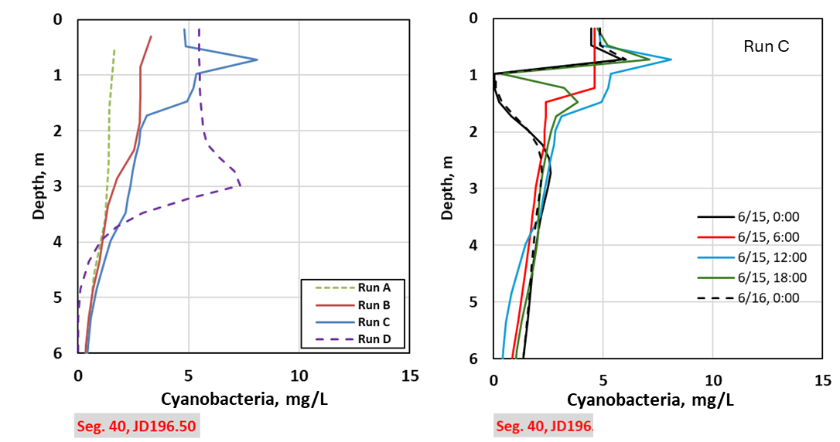
Figure 1. Simulated cyanobacteria concentration profiles at segment 40 (a) for JD 196.00 (July 15th, 18:00) for Run A, B, C, and D, and (b) for Run C 6/15 0:00, 6:00, 12:00, 18:00 and 6/16 0:00.
- The 0.25 m grid (Run C) indicates that CE-QUAL-W2 can provide finer details in thermal stratification and associated cyanobacteria vertical distribution that varies notably over the course of a day.
- While no field data were available for confirmation, the logic to represent vertical migration allows for a realistic representation of the distribution of buoyancy compensating algae in the near surface waters of the reservoir over a diurnal cycle.
- When AVM logic is not used (Run D), the simulations generally distribute cyanobacteria in the top 2 to 4 m without the detail of Runs B and C. Additionally, the biomass of cyanobacteria is larger in Run D. This suggests that simulating cyanobacteria in W2 with AVM may require a different parameterization of algal dynamics than a simulation where it is not used.
- The loss function at the bottom of the active zone can result in a notable loss of standing crop over time. Conservation of mass (biomass) is a consideration when applying the models to ensure they represent the system in questions.
- If buoyancy compensating logic is employed, field data should be collected at appropriate spatial and temporal scales to calibrate model parameters to ensure standing crop is properly represented.
- Further model testing to assess impacts of the loss function as well as other factors (model parameterization, meteorology conditions, grid resolution (including branches), etc.) on simulation results should be considered.
In summary, the vertical migration logic in CE-QUAL-W2 appears to provide useful insight into buoyancy compensating cyanobacteria dynamics, particularly with a finer vertical layer height. Detailed spatial and temporal monitoring will be required to calibrate and verify model performance if relying on the model to produce harmful algae blooms for management purposes.
Conceptual Model. The conceptual model for AVMs is discussed in Appendix 1.
Level of Effort. The level of effort associated with additional testing of W2’s AVM logic is estimated to be moderate. The testing may combine additional sensitivity analysis with application to a well-observed system to better assess skill.

Nitrogen Fixation (CE-2)
Importance. Accurate characterization of cyanobacteria behavior under different nutrient regimes is important for useful simulation of HABs.
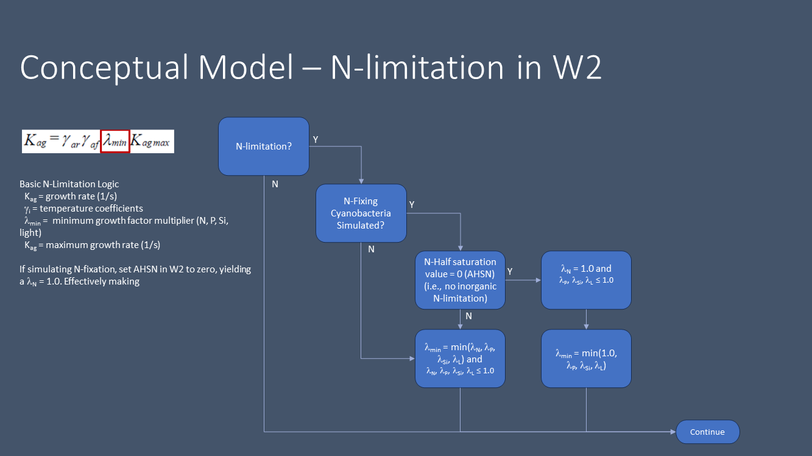
Conceptual model. CE-QUAL-W2 can represent nitrogen fixation by setting the half saturation constant for nitrogen fixing cyanobacteria. There are cyanobacteria that are not nitrogen fixers and still produce toxins and nuisance conditions. Representing the full suite of HABS may require multiple cyanobacteria groups (N-fixers and non-N-fixers) if there are multiple cyanobacteria producing nuisance conditions. CE-QUAL-W2 can be used to model general attributes of bloom conditions that would be useful for lake managers to assess the potential for HABs and explore options to manage HABs.
Setting the half-saturation constant to zero results in the limiting factor (or fraction) for nitrogen uptake to equal 1.0 (no limitation). This is effective in both addressing N-fixation as well as properly representing the input of N2 into the aquatic system. Algae biomass in the model is governed by the stoichiometry of the algae, thus when the half-saturation constant of N update is set to zero, the associated amount of nitrogen (organic) introduced to the system via N-fixation is appropriately included in the cell biomass.
One challenge using the current approach is that nitrogen fixation may occur when inorganic nitrogen (NO3 and NH4) is present in the system. Heterogeneity in algal distribution; heterogeneity in the concentration of inorganic nitrogen and other nutrients; cyanobacteria colony morphology, and other environmental factors can contribute to nitrogen fixation occurring when there are notable inorganic nitrogen concentrations present.
Level of Effort. Potential approaches to modeling the onset and degree of N-fixation, akin to nitrification inhibition and/or Monod kinetics, can be considered for future implementation in CE-QUAL-W2 and would require modest code changes, but more extensive testing and possibly field experiments to effectively parameterize. The necessary level of effort is therefore estimated to be low to moderate, depending on the level of testing and field experimentation.

Hypoxic Conditions (CE-3)
Importance. Algal dynamics can be heavily impacted by hypoxic conditions potentially inhibitive of growth and respiration. However, W2 currently does not include logic to adjust growth and/or respiration rate based on dissolved oxygen levels.
Conceptual model. Algae respire continuously to maintain metabolic processes, and consumes oxygen and produces carbon dioxide. Photosynthesis is use of sunlight (radiant energy) during daylight hours to convert water and carbon dioxide into glucose, and as a biproduct produce oxygen (O2).
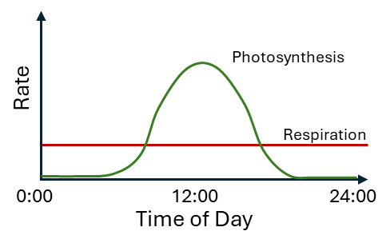
Figure 3. Conceptual rates of algal photosynthesis and respiration
over a typical day during the growth season.
Under certain conditions in certain systems, nighttime dissolved oxygen (DO) concentrations can drop to low levels (in response to oxygen demands in the water body, low rates of reaeration, and algal respiration). Under such circumstances, DO concentrations may be insufficient to support algal needs. The response varies, but DO may lead to increased algal mortality, increased algal respiration, or other stress to the algae community (e.g., susceptibility to pathogens (cyanophages for HABs)). The response is most likely non-linear, with decreasing DO concentrations having ever increasingly adverse impacts (versus a simple step function where below some critical DO concentration there is an abrupt change in algal community response). Further, response is not expected to be the same for all algae, with certain algae more tolerant of low DO conditions.
Developing logic for inclusion in CE-QUAL-W2 is probably fairly simple: DO could be represented akin to nitrification inhibition or other Monod kinetics where there is a gradual onset of conditions, the rate of which can be controlled by a coefficient (in the examples, a nitrogen inhibition coefficient or a half-velocity (or half-saturation) constant). Determining coefficients and/or constants for a relationship may be challenging for a wide range of algae due to a lack of available literature. However, including this feature in W2 would probably provide a useful approach to modeling hypereutrophic waters where extensive algae bloom occur (including bloom “crashes”) and low nighttime DO concentrations are observed. Simple logic increasing mortality and reducing algal growth rates under low DO was introduced into a version of CE-QUAL-W2 logic for assessment of water quality conditions in Keno Reservoir on the Klamath River to represent algal conditions under persistent anoxic conditions (PacifiCorp 2005 and ODEQ 2010), but is not included in the public release version of CE-QUAL-W2.
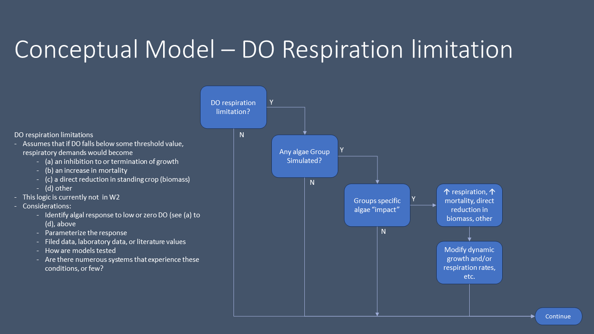
Figure 4. Graphical representation of conceptual model.
Implementation will require additional inputs to indicate whether a DO-based correction to growth and respiration rates is included, and to define the form of that correction. Additional code will be needed to process the new inputs and to calculate and use DO-corrected rates in the simulation. Literature, lab, or field research evaluations of DO-dependent behavior may also be needed.
Level of Effort. The level of effort for implementation in model inputs and code is estimated to be low. Supporting research may require low to moderate additional efforts.

Minimum Algae Concentration (CE-4)
Importance. During W2 simulations of non-growth seasons, algal concentrations can drop to zero, leaving no standing crop to build from. A common W2 workaround has been to seed the system through boundary inflows of background concentrations, though this can produce unrealistic distributions of simulated algae or unrealistic inflow concentrations. Other models have a minimum concentration for algal groups to support regrowth. Implementation of a similar feature will simplify handling of standing crops.
Conceptual Model. A challenge in simulating algae over multiple years (seasons) or during a period when simulated concentrations drop to zero does not allow the model population to re-build a population once conditions that support algae growth return. One common remedy is “seeding” the model by introducing algae into the model domain via inflows (e.g., using a boundary condition). Limitations here include, but are not limited to:
- for a large lake this could produce unrealistic distributions of simulated algae because populations near the inflow points may be far from the main body of the lake or outflow points;
- for small inflows (stream inputs of a few cfs) into large lakes (storage greater than 100,000 acre-feet), introducing sufficient algae concentrations via boundary conditions may be inadequate to properly represent algae conditions in the system.
In some models a minimum algae concentration for each algae group is specified so that the concentration does not drop to zero, maintaining a low level of algae allowing for re-growth should light, nutrient, temperature, and other conditions return to levels supporting the algae group. A minimum is consistent with natural systems were most species of algae are present in one form or another year-round, but often a low levels. When species are not present algae reproduction can start from resting cells (autospores), other spores (aplanospores, autospores), and in cyanobacteria, akinetes (dormant, spore-like cells). While these complex reproductive dynamics are not included in CE-QUAL-W2, setting a minimum algae concentration would provide a proxy to assess re-growth of algae spatially in response to environmental conditions (re-growth may occur at different times and different rates in different parts of the lake) without the challenges of “seeding” the system via boundary conditions.
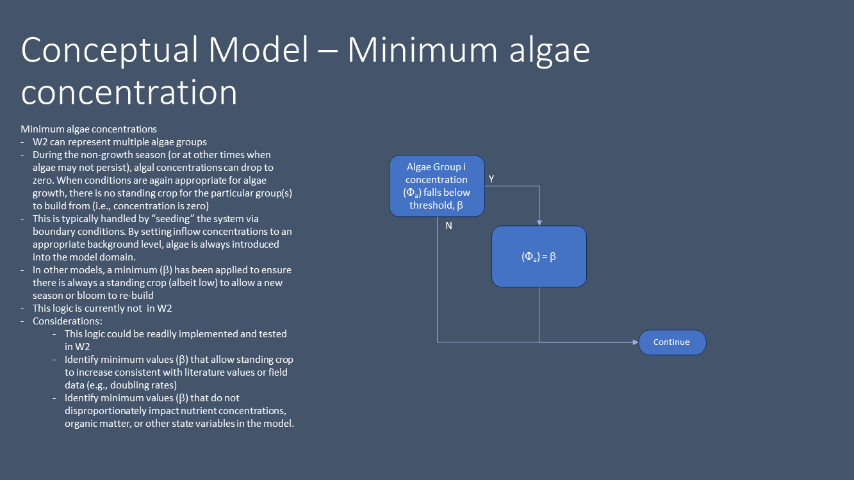
Implementation will require additional inputs to signify use of the option and how to specify the desired minimum concentration of algae. Further discussion is needed to determine whether this should be a systemwide value spatially or by algal group. Additional code will be needed to process the new inputs and to enforce the minimum concentration in algal calculations.
Level of Effort. The level of effort for implementation is estimated to be low.

Treatment Regimes (CE-5)
Importance. Simulation in W2 of the impacts of different treatment regimes on HABs can usefully inform HABs management decisions for water bodies. There is a wide range of management options in the literature, with the North American Lake Management Society identifying 31 major physical, chemical and biological controls [NALMS 2001]. Not all controls can be simulated in W2; however, Watercourse Engineering’s recent work [citations] as summarized in Table 1 lists nine water quality control strategies that can be evaluated using W2.
There are three strategies in the table that were selected for additional inspection: algae harvesting, alum treatment, and algaecide treatment.
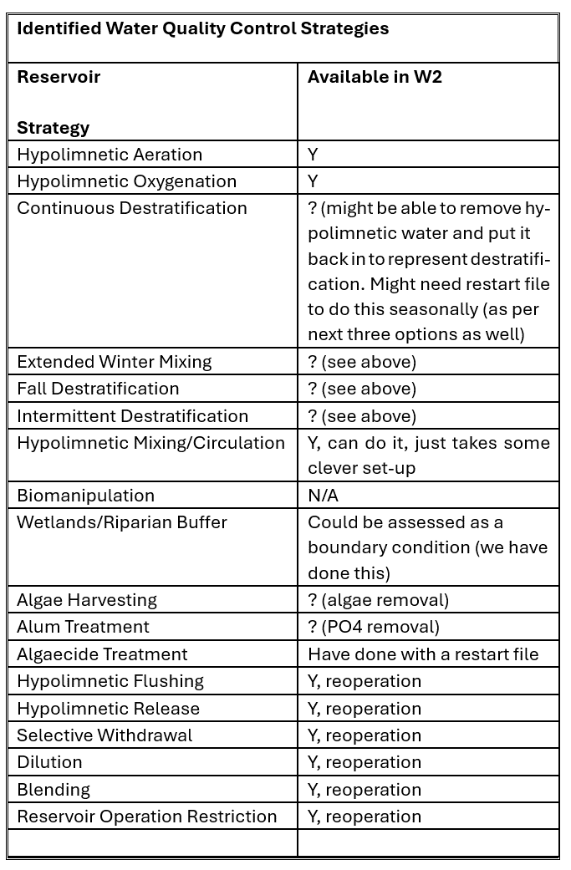
Table 1. Water Quality Control Strategies Assessed by Watercourse Engineering
Conceptual Model. For each of the three strategies, changes are suggested for code and inputs:
- Algae harvesting is conceptualized here as the mechanical removal of algae from the water column, such as by surface skimming. The removal may be parameterized in terms of timing, effectiveness and extent:
  - Timing identifies the model time step (T_{r}) at which the removal will take place. The removal is assumed to be instantaneous.
  - Effectiveness characterizes the removal efficiency of the harvesting operation as the fraction of total biomass that is captured (F_{r}). The effectiveness is assumed to be the same for all species and for all segments.
  - Extent identifies the segments from which algae will be removed([s]) and the estimated fraction of each segment which will be subjected to removal (F_{r,s}).
At time T_{r}, a fraction (F_{r} x F_{r,s}) of algal mass will be removed from each segment s in the removal extent.
- Algaecide treatment is conceptualized as mechanical distribution of an algaecide to kill algae. The addition may be parameterized in terms of timing and extent:
  - Timing identifies the model time step (T_{a}) at which the distribution of algaecide will. The addition is assumed to be instantaneous.
  - Extent identifies the segments which will be affected by the distribution of algaecide ([s]) and the fraction of the segment impacted (F_{a,s})
At time T_{a}, a fraction (F_{a,s}) of algal mass in each impacted segment s will die off. The dead algae remain in the system.
- Alum treatment is conceptualized as mechanical addition of alum to the water column to precipitate out nutrients and thereby limit algal growth potential. The addition may be parameterized in terms of timing, extent, and dosage:
  - Timing identifies the model time step (T_{d}) at which the addition of alum will will take place. The addition is assumed to be instantaneous.
  - Extent identifies the surface segments to which alum will be added ([s]).
  - Dosage defines the mass of alum (M_{s}) that will be added for each segment
At time T_{d}, mass (M_{s}) of alum will be added to each surface segment s in the dosage extent. The alum will react with available nutrients and precipitate out and settle to the bottom. This may require implementation of a new state variable to represent alum.
Level of Effort. The level of effort is estimated to be low for implementing algae harvesting, moderate for algaecide, and moderate to high for alum treatment.
Recommendation. Implement algae harvesting; consider whether assumption of instantaneous timing is reasonable for all three.

Review for Relic Code (CE-6)
Importance. During the W2 discussions between ERDC staff and the contractor team, concerns were raised that there may be assumptions and algorithms in the code that reflect W2’s origin as a BOD-oriented eutrophication model. These assumptions and algorithms may inadvertently affect results in the newer carbon-based model framework. For example, there may be flags or inputs whose meanings and/or use are different when ORGC is changed, leading to unexpected simulation results.
Conceptual Model. N/A.
Level of effort. The level of effort is estimated to be low, with activities including review of documentation and selected portions of the code. Attention may be paid to changes between version 2.x and 3.0. A possible outcome is a brief guide for developers to ensure new code explicitly avoids ambiguity and to support opportunistic review of existing code.

Documentation of Best Practices (BP 0-7)
Importance. Discussions between contractor and ERDC staff and with stakeholders during the conduct of this task and of the previous work under Task 1 of Delivery Order W912HZ23F0288 highlighted that W2 already has robust capabilities for modeling HABs. However, most potential W2 users will not be familiar with these capabilities and therefore will skip or misuse them. Documentation of HABs best practices was identified as a useful enhancement for the W2 modeling community.
Conceptual Model. Documentation of best practices is anticipated to consist of a mix of brief technical notes and case studies, preferably in an electronic format suitable for multimodal sharing (e.g. print, web, desktop). Identification of the preferred format and development of an outline or template will make creation of such documentation earlier, as will identification of the sharing mechanism – which will likely intersect with the Useful Tools (UT) and User Community (UC) topics presented below.
Implementation will start with development of a template and selection of the sharing mechanism (BP-0). Seven candidates for documentation have been identified to date:
- Model Appropriateness (BP-1).
  - Should I use W2 or not?
- Data Needs (BP-2).
  - What data are needed to accurately (enough) simulate HABs in W2
- Segmentation (BP-3).
  - What strategies can be applied to improve vertical and lateral resolution?
- Light Extinction (BP-4)
  - How should light extinction be parameterized to minimize uncertainty?
- Treatment Regimes (BP-5)
  - How have different treatment regimes been successfully simulated in W2?
- Algal Community (BP-6)
  - What level of detail is appropriate to capture spatial and temporal dynamics, and/or functional specialization, and what data are necessary for this?
- Risk and Uncertainty (BP-7)
  - How can W2 be applied or interpreted to understand uncertainty and risk?
Level of Effort. Development of a template and selection of sharing mechanisms require a low to moderate level of effort. Documentation of individual topics will likely each also require a low to moderate level of effort.

Sharing Useful Tools (UT)
Importance. During the online workshops held under Task 1 of the previous Delivery Order (W912HZ23F0288) several participants talked about tools developed to support W2 applications, such as Stewart Round’s W2-anim and W2 post-processor, Erik Smith’s calibration tool and Norm Buccola’s water balance calibration utility. The tools raised interest among stakeholders, and discussion led to the notion of a clearinghouse for useful W2 tools.
Conceptual Model. Identification and collection of useful tools may be best accomplished within a community. Standards or recommended guidelines for distribution (possibly including safe sharing as open-source code rather than executables) and documentation should be developed, and a sharing mechanism is needed as well. This activity will overlap with the Best Practices (BP) and User Community (UC) activities
Implementation will include development of guidelines, selection of a sharing mechanism, and packaging and posting of one or more useful tools.
Level of effort. Implementation will require low to moderate effort.

Building a User Community (UC)
Importance. The long-term sustainability of W2 can be enhanced by a strong and engaged community of users and developers. Existing shared resources like the CE-QUAL-W2 Wiki and the W2 Forum may provide a basis for that desired engagement, though it is unclear how active members are in these forums.
Conceptual Model. Development of a strong and engaged user community may require the following steps:
- Definition of Purpose and Audience
- Selection of Platform
- Fostering of Open Communication
- Providing Useful Content
- Facilitating Collaboration
- Delivering Incentives and Recognition
- Leveraging Social Media
- Building Partnerships
- Measuring and Evaluating
These steps were identified using the Google Gemini AI Model. Additional detail is presented in Appendix 2.
Level of Effort. Implementation of a sustainable and engaged user community will require a moderate to high level of effort.

Leveraging High-Resolution Datasets (HR 1-5)
Importance. High-resolution datasets consisting of either observed data or model results are increasingly available. These datasets may serve to improve W2 model inputs – most likely through upscaling to aggregate high-density (in space and/or time) datasets to match coarser W2 time steps or through downscaling of laterally-averaged W2 results to finer scales.
Conceptual Model. For the purposes of this discussion, upscaling is considered a pre-processing activity and downscaling is a post-processing activity. An upscaling pre-processor will need to be aware of the formats for the dataset of interest and of the targeted W2 inputs, and implement a valid scheme to appropriately map and aggregate spatially/temporally dense data. Similarly, a downscaling post-processor will need to be aware of the formats of W2 results and implement a valid scheme for disaggregating coarse(r) W2 outputs in manner informed by the high-resolution dataset.
Five different types of high-resolution datasets were identified during this project:
- Wind fields (HR-1)
  - Upscalable to a boundary condition
- Hyperspectral imagery (HR-2)
  - Upscalable to initial conditions reflecting observed distribution of algae
- High-frequency observations (HR-3)
  - Upscalable to boundary conditions (e.g. 5-minute DO)
- Imagery (hyperspectral or otherwise) (HR-4)
  - Informs downscaling of algal mass to distribute laterally-averaged mass
- 3-D hydrodynamic models (HR-5)
  - Adds refined segmentation and transport to distribute laterally averaged mass
The implementation assumes no feedback relationships between new tools and the W2 model.
Level of Effort. Implementation of useful tools in the form of high-resolution dataset-aware pre- and post-processors will require moderate to high effort.

Prioritized Implementation Roadmap
This task identified 21 distinct opportunities for enhancement of W2 capabilities for modeling HABs:
ERDC and contractor staff were asked to consider this list of opportunities and rank according to their individual judgment. Rankings were then combined to arrive at a prioritized roadmap for implementation.
An initial recommendation was made to start with a combination of CE-2 (Nitrogen Fixation), CE-4 (Minimum Algae Concentration), CE-3 (Hypoxic Conditions), CE-5 (specifically algal removal by skimming), and BP-0 (Documentation Infrastructure) with BP-1 (Model Appropriateness). The level of effort for these particular opportunities is estimated to be Low (Low to Moderate for CE-2), so this grouping is consistent with the currently modest funding available for implementation under Task 2. CE-1 (Vertical Migration) was omitted from this recommendation because the conceptualized effort is related to additional testing of the existing code rather than a direct improvement , while BP-2 (Data Needs) is omitted because the level of effort could be more than desired.

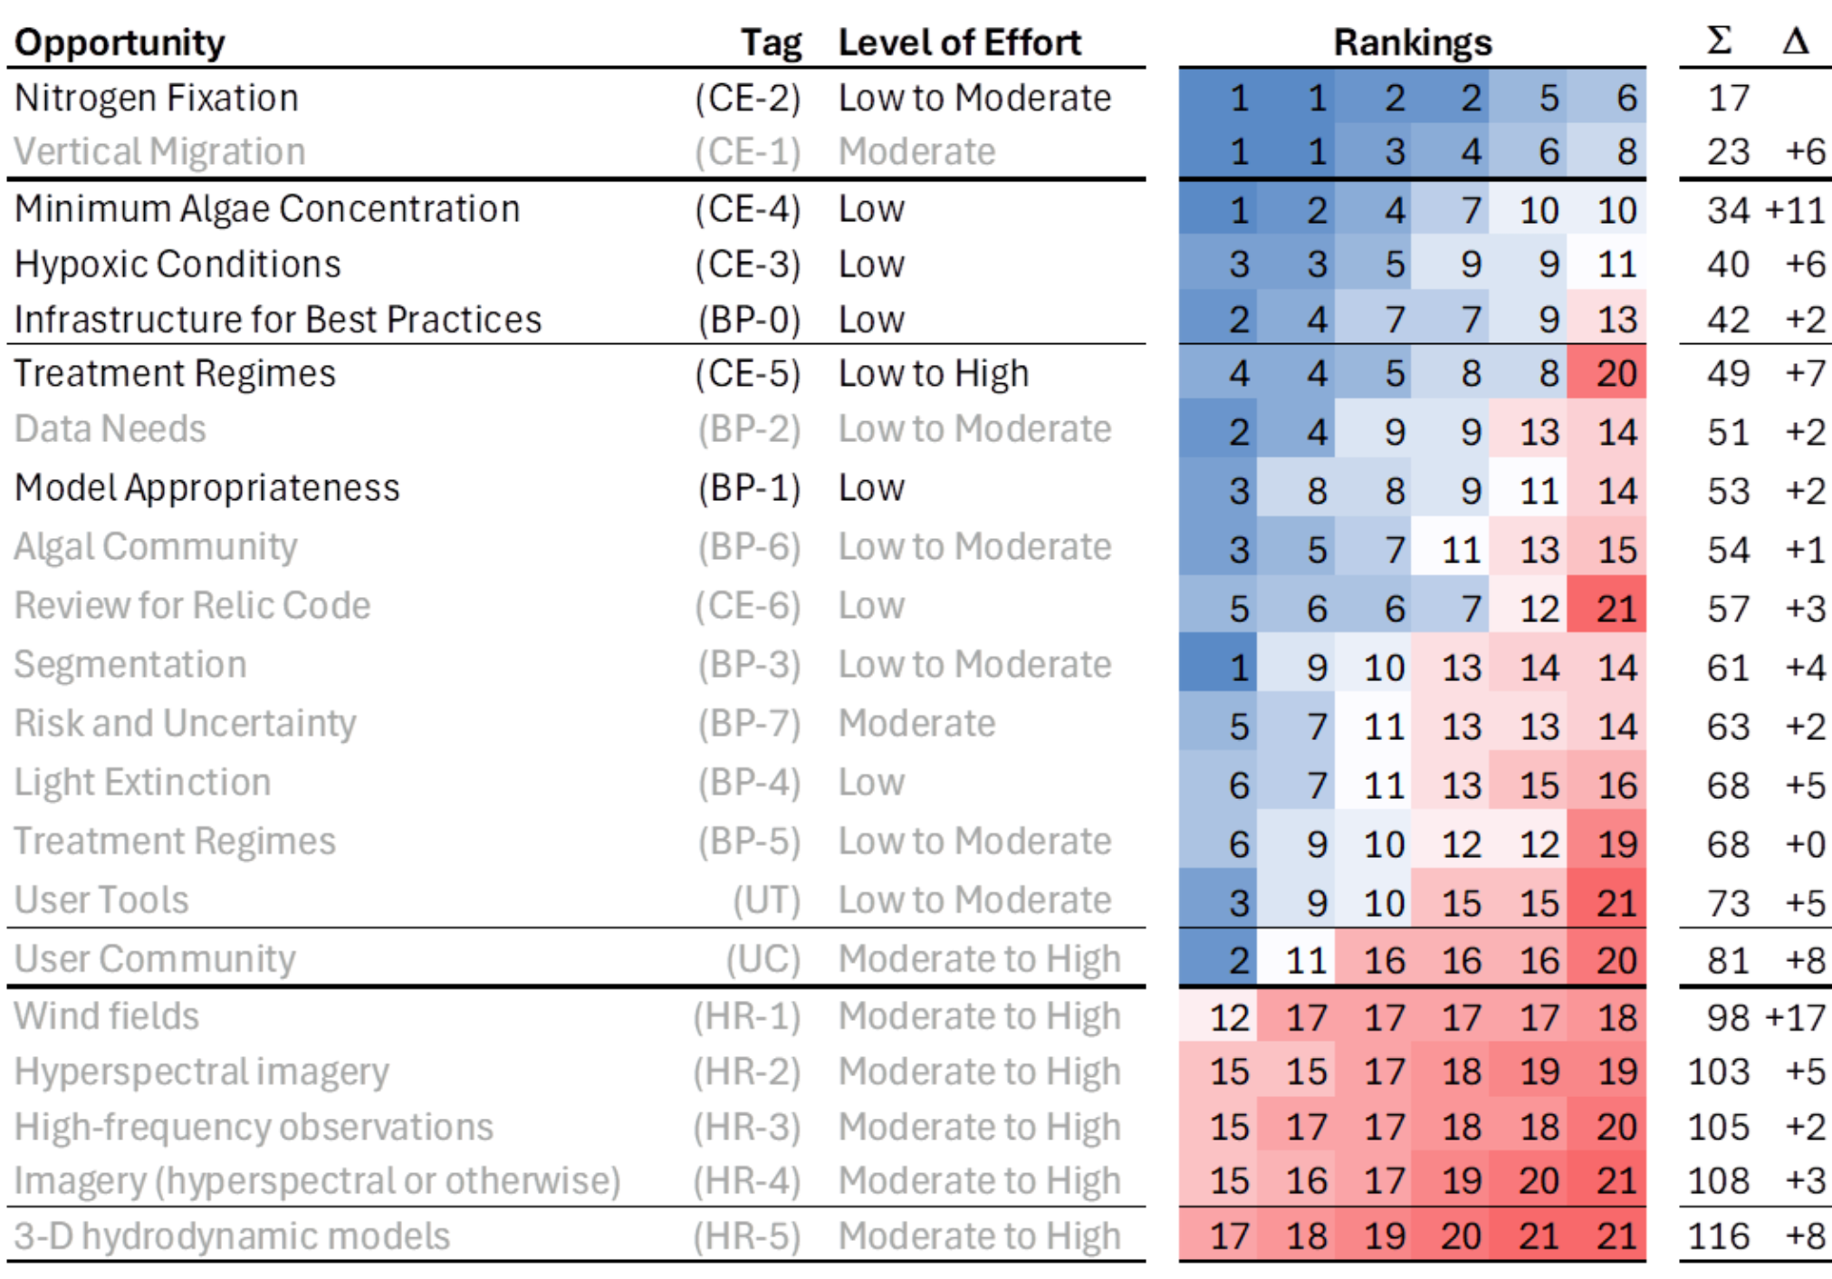

Next Steps
Based on Project Team discussions, the following four code enhancement opportunities were selected for implementation in the follow-on task (“Implementation of Harmful Algal Bloom algorithms for CE-QUAL-W2”):
- Minimum Algae Concentration
- Mechanical Removal (Treatment Regimes)
- Hypoxic Conditions
- Nitrogen Fixation

Appendix 1 – Watercourse W2 AVM Exploratory Analysis

 | Technical  Memorandum

Date: July 25, 2024

To: Tad Slawecki, Limnotech

From: Ert Sogutlugil, Watercourse Engineering, Inc.
Mike Deas, Watercourse Engineering, Inc.

Re: Brief Analysis of the Algae Vertical Migration Model in the CE-QUAL-W2: DRAFT

Abstract
Some species of cyanobacteria can move vertically in the water column by regulating their buoyancy. Main external factors affecting this mechanism are light and nutrients. Model logic representing algae vertical migration related to buoyancy regulation is included in CE-QUAL-W2 model in version 4.5. This technical memorandum outlines the details of a brief analysis performed using this logic.
- Algae Vertical Migration Model
CE-QUAL-W2, Version 4.5 model (Wells 2023a), includes a cyanobacteria vertical migration sub-model based on works by Overman (2019), Overman and Wells (2021), and Cervarich et al. (2020). Cyanobacteria adjust their buoyancy with carbohydrates or gas vesicles (Kromkamp and Walsby, 1990). Accumulation of carbohydrates and collapse of gas vesicles in cells through photosynthesis decrease buoyancy gradually during daylight whereas depletion of carbohydrates and formation of new gas vesicles after photosynthesis increase buoyancy. Four different algae vertical migration (AVM) models, termed “Continuum Model” in the CE-QUAL-W2 terminology, were added to the model. If the parameter AVERTM is turned ON in the main input file “w2_con.csv” for any group of algae, the input file “w2_AlgaeMigration.csv,” which includes the assigned continuum model and the related parameters, is activated. The four continuum models mentioned are:
- model 1 (settling velocity, which will be termed as “velocity” for the rest of this document, depends on time only),
- model 2 (velocity depends on time and space (a limit to vertical migration),
- model 3 and 4 (velocity depends on density growth),
For the first two models, movement of cyanobacteria are formulated by the predefined velocity in simple sinusoidal function which considers change in light through the day. For model 1, the velocity function depends only on time, whereas in model 2, the velocity function depends both on time and space (a vertical limit to movement). For models 3 and 4, the dynamic velocity approach which reflects the organism’s response to variations in solar irradiance is used. For that purpose, organism velocity is based on relationships between sunlight, cyanobacteria growth and density (e.g., colonies or overall biomass). As expected, the dynamic velocity approach, i.e., models 3 and 4, was found to be increasing the CE-QUAL-W2 run time significantly because the model is computes density in every model grid cell at each time step.
This analysis was focused on model 2, because it was deemed most representative to limit vertical migration to a pre-determined depth to complete the testing explained in the next section. For detailed information on models 3 and 4, the reader is referred to the CE-QUAL-W2 user manual (Well 2023a and Wells 2023b).
  - Model 2
The velocity function ($v_{p})$ for model 2, which depends on space and time, (Belov and Giles (1997) is given in Eq. 1.
$v_{p}\left(t,z\right)=\left\{\begin{aligned}A\frac{2π}{86,400s}cos\left(\frac{2π}{86,400s}t+φ\right)e^{-α\left(H-z\right)}, I_{o}>0 \\ A\frac{2π}{86,400s}cos\left(\frac{2π}{86,400s}t+φ\right), I_{o}≤0 \end{aligned}\right.$ (Eq. 1)
Where:
$t$: time (seconds) through one day,
$z$: depth (m),
A: amplitude (m),
$φ$: phase shift (rad),
α: light attenuation coefficient (“CalibrationCoefficientExtinction” in “w2_AlgaeMigration.csv” input file),
H: user supplied depth parameter (m) (“ExpDepth” in “w2_AlgaeMigration.csv” input file),
$I_{o}$: solar irradiance at the water surface
During daytime, the model uses the first line in Eq. 1 so that the effects of water clarity (a function of light extinction) and depth on the velocity function are also considered. When there is no sunlight present, the model uses the second relationship (I_{o} ≤ 0).
In this analysis, the parameters and their assigned values for model 2 are listed in Table 1. The same model 2 was used for all the simulations presented herein.

Table 1. Parameter values used in model 2.
Parameter (unit) | Value
Amplitude (m) | 2.00
Phase shift (rad) | 1.570796
Light Attenuation Coefficient | 0.30
Depth parameter (m) | 12.00

Based on values listed in Table 1, the velocity function at four different depths (5 m, 10 m, 15 m and 20 m) through the day is included as an example (Figure 1) in which the entire day (86,000 seconds) is represented as daytime and nighttime for the top graph and the bottom graph, respectively.
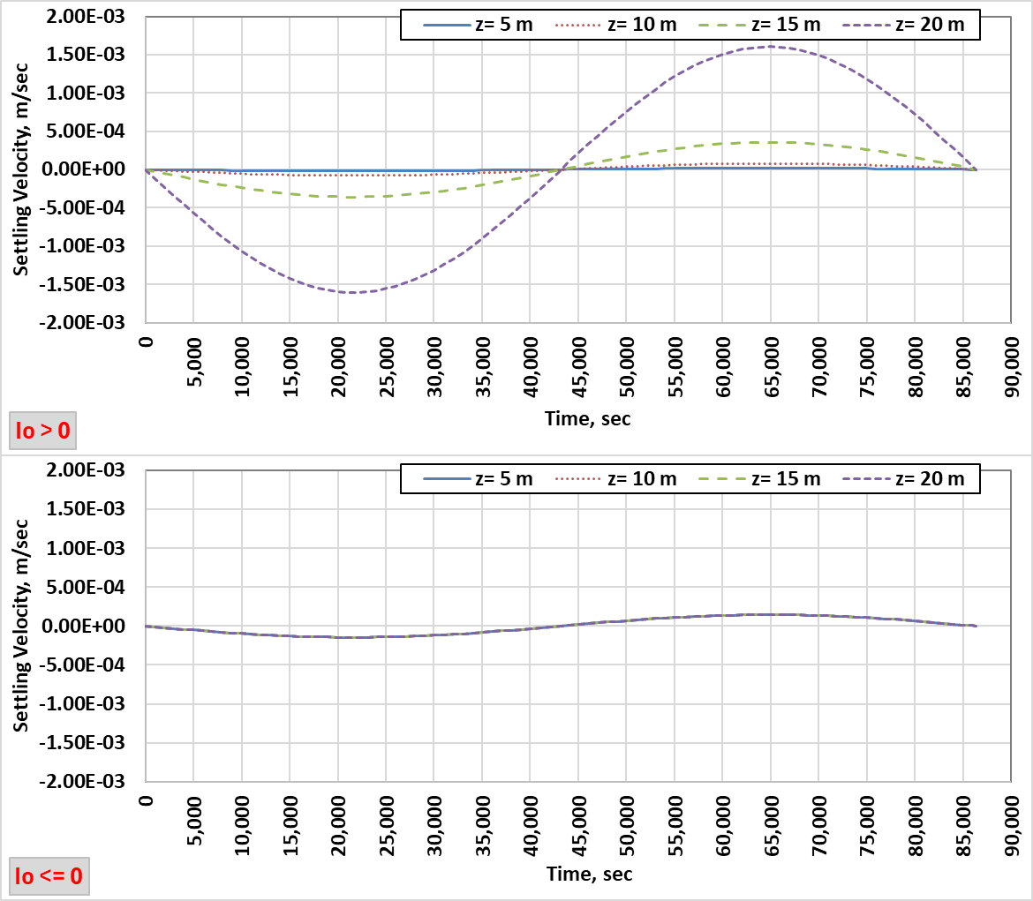
Figure 1. Cyanobacteria velocity through daytime (top) and nighttime (bottom) at four different depths.
In Figure 1, positive values correspond to downward movement. During daytime, the velocity increases significantly as the depth increases and it is highly dependent on the user defined depth parameter (H). During nighttime, the velocity is relatively slow and the same through the water column as the related part of the function depends on time only.
In addition to the parameters mentioned above, there are two other parameters that affect the cyanobacteria location and its concentration: “Depth Limit” (m) and “LossFraction.” These parameters were assigned the values of 1.00 and 0.10, respectively, in this analysis. Depth limit indicates the depth which cyanobacteria stop once they reach. This is imposed on the migration only if the AVERTM switch is turned ON. The loss fraction is the fraction of biomass lost once they interact with the bottom of the system (in this example, 10 percent).
- Model Grid
For this analysis, the model grid of a current CE-QUAL-W2 model of a representative reservoir flow and water quality model was used. The original layer height of 1.0 m for the whole grid (Grid A: Run A) was changed to create two other grids with 0.5 m layer height throughout the model (Grid B: Run B), 0.25 m in the top 9 m and 0.5 m layer height for the remainder of the model (Grid C: Run C). Grid C was also used without the AVM module (Grid C: Run D). The grids mentioned, and the associated runs and AVM models are listed in Table 2.
Table 2. Model grids and the associated runs.
Model Grid Name | Run Name | AVM Model (Model 2)
Grid A (1.00 m of layer height for the whole grid) | Run A | Used
Grid B (0.50 m of layer height for the whole grid) | Run B | Used
Grid C (0.25 m and 0.50 m of layer heights for the top 9.0 m and the rest of the grid, respectively) | Run C | Used
Grid C | Run D | Not used

One of the updated grids, Grid C, is included in Figure 2.
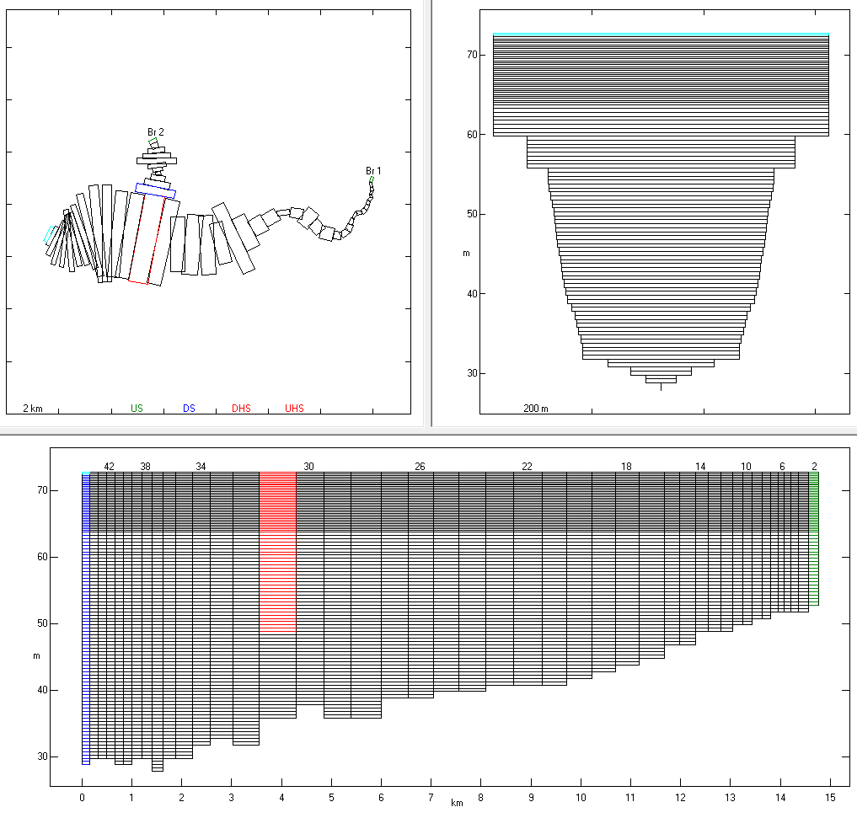
Figure 2. Grid C. Plan view (upper left), cross section of the most downstream segment of the main branch (upper right) and side view of the main branch with some of the segment numbers indicated (bottom). In the plan view, the most upstream segments of each branch are shown in green; terminal downstream segment of Branch 2 is blue; “connection” segment of the main branch (Branch 1) to Branch 2 is red; and most downstream segment of the entire model grid, just above the dam, is cyan.
- Model Inputs
Historical data for flow, temperature and meteorological data/inputs were used in the model. In addition representative historical water quality data/inputs, number and types of algae and the related parameters were derived from an existing model. Some of the water quality inputs and most of the values assigned for algae parameters were modified for the three algae types simulated to ensure that cyanobacteria were the dominant form in the growth season, while the concentration of the other two algae groups remained at low concentrations between June 1st and October 1st. In short, the model inputs used in this analysis are representative, but do not necessarily represent the existing system (i.e., this is not a water quality model calibrated for full water quality and algal groups). The main purpose for creating the data set mentioned was to observe the cyanobacteria response to the AVM model applied/used in different gid resolutions.
Model flow and temperature inputs are included in Figure 3 and Figure 4, respectively. While the inflows were different, the same temperature and water quality inputs were used for both branches.
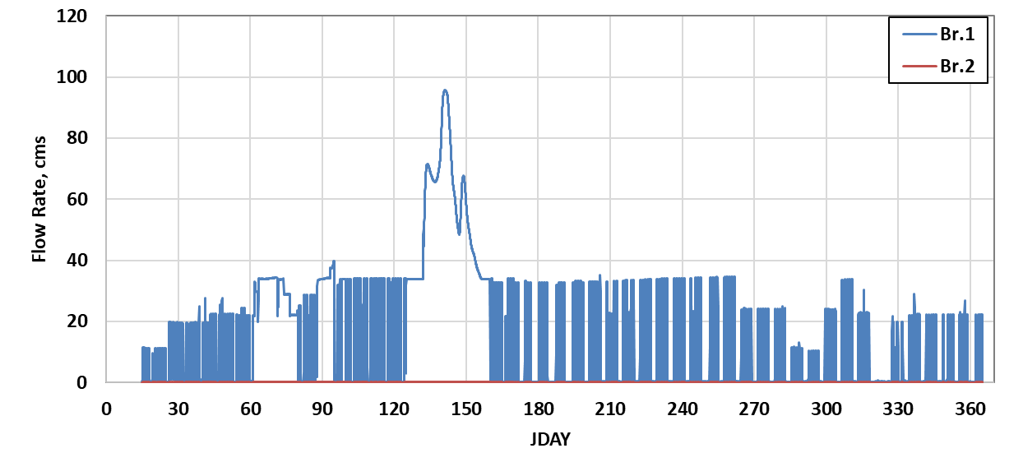
Figure 3. Inflow for branch 1 and branch 2.
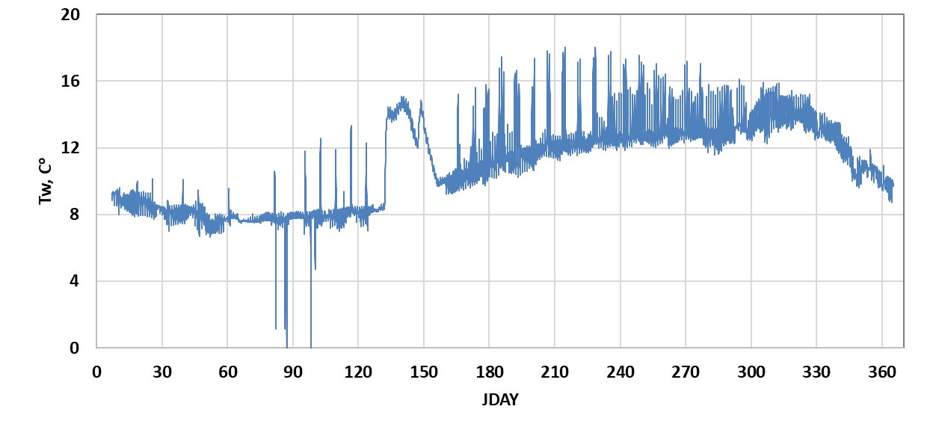
Figure 4. Inflow temperature.
Selected water quality inputs; dissolved oxygen, ammonium and phosphate are included in Figure 5 whereas nitrate, labile dissolved & particulate organic matters, refractory dissolved & particulate organic matters and three types of algae are included in Figure 6.
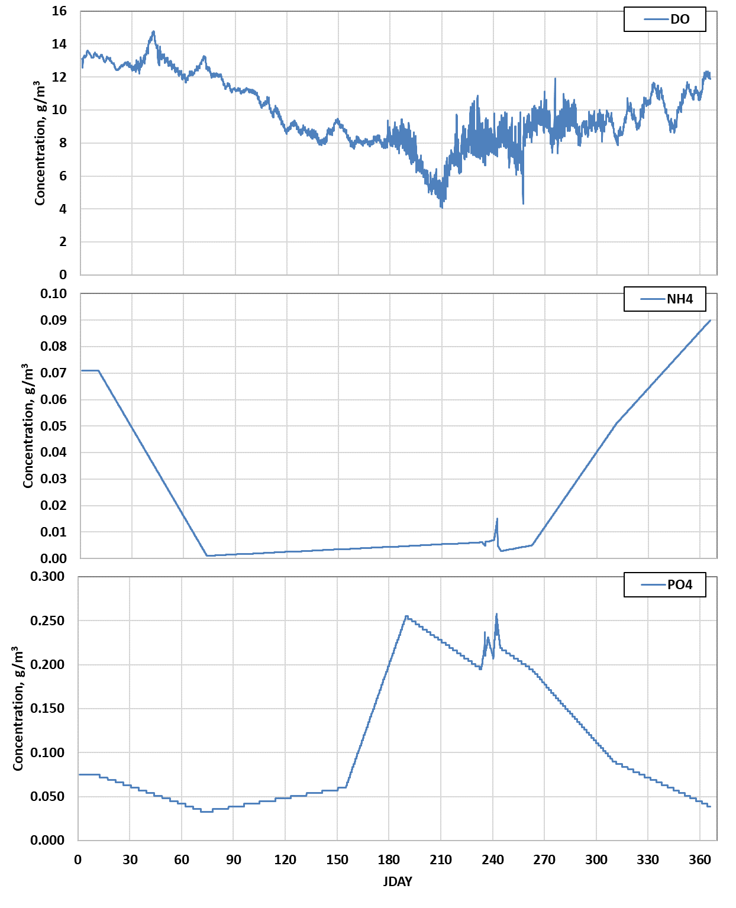
Figure 5. Dissolved oxygen (top), ammonium (middle) and phosphate (bottom) inputs.
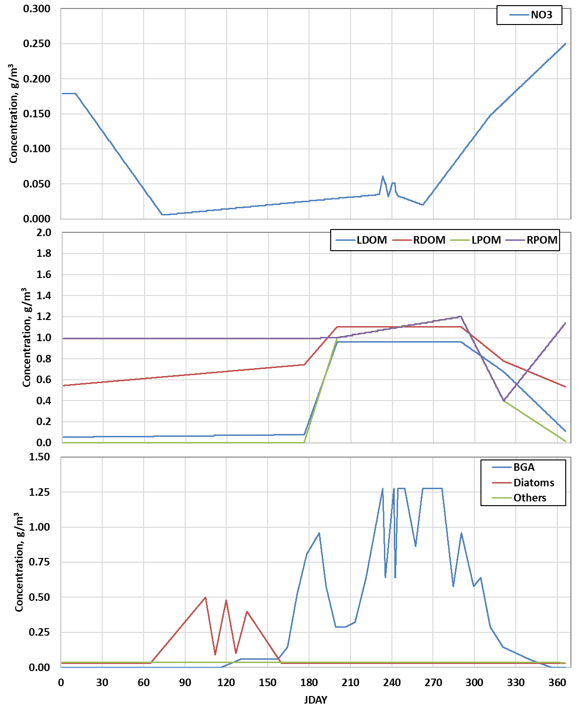
Figure 6. Nitrate (top), labile and refractory dissolved & particular organic matters (middle) and three algae types (bottom) inputs.
Kinetic rates/parameters for algal growth, mortality, excretion, respiration and settling, and half saturation constants for nutrients, and saturated light intensity are also important factors impacting simulated algae concentrations. A snapshot of the main input file section, which includes the algal parameters mentioned above and the values assigned for this analysis, is included in Figure 7.
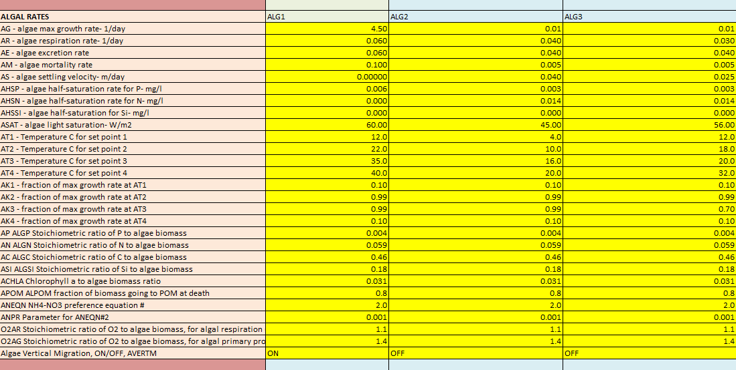
Figure 7. Algal rates and their values for the analysis.

- Model Results and Findings
The model layout includes a main branch (branch 1) and second branch (Figure 2). A limited amount of testing was completed to look at variations between branch 1 and 2 to ascertain if representing the smaller, shallower, branch 2 explicitly may result in different algal concentrations. Little difference was found between branch 2 and the main reservoir (branch 1) in the proximity of branch 2. Additional testing would be required to explore parameterizing the CE-QUAL-W2 to further determine if this increased spatial representation could more comprehensively represent lateral cyanobacteria conditions.
The focus of this effort was testing the vertical migration logic over a range of vertical grid resolutions. Cyanobacteria take advantage of stable thermal regimes in the epilimnion where their buoyancy compensation ability allows them to outcompete other species (Perl and Huisman 2009, Huisman et al. 2004, Livingstone 2003). Increasing the vertical resolution of the model provided an opportunity to (a) determine if CE-QUAL-W2 would effectively reproduce refined temperature gradients in near surface waters and (b) identify potential differences in cyanobacteria migration using the aforementioned logic.
Through the model period including summer and fall, results of the four model runs: Run A, B, C, D (Table 2), where Run D did not employ the vertical migration logic. Simulated temperature, cyanobacteria, and dissolved oxygen are presented for a representative day and time (July 15th, 12:00 PM) in Figure 8 through Figure 11.
These results indicate that grid resolution did not particularly impact the overall thermal regime of the reservoir for the more refined vertical resolution cases (Runs B, C, and D). The 1 m vertical resolution grid had a deeper thermocline. Differences in dissolved oxygen distribution are apparent at the headwater of the reservoir (Figure 8 versus Figure 9, Figure 10, and Figure 11) where the higher resolution grids represented the interflow of inflow concentrations appear to be better represented, regardless of cyanobacteria vertical migration logic being used or not (Figure 10 and Figure 11). Cyanobacteria distribution is markedly affected by grid resolution, where the 1 m grid (Run A) showed little vertical segregation while the 0.5 m (Run B) and 0.25 m (Run C) grids indicated clear vertical segregation with the vertical migration logic implemented. When this logic was not used, there was no appreciable vertical segregation, even using the finest resolution grid (Run C, D).

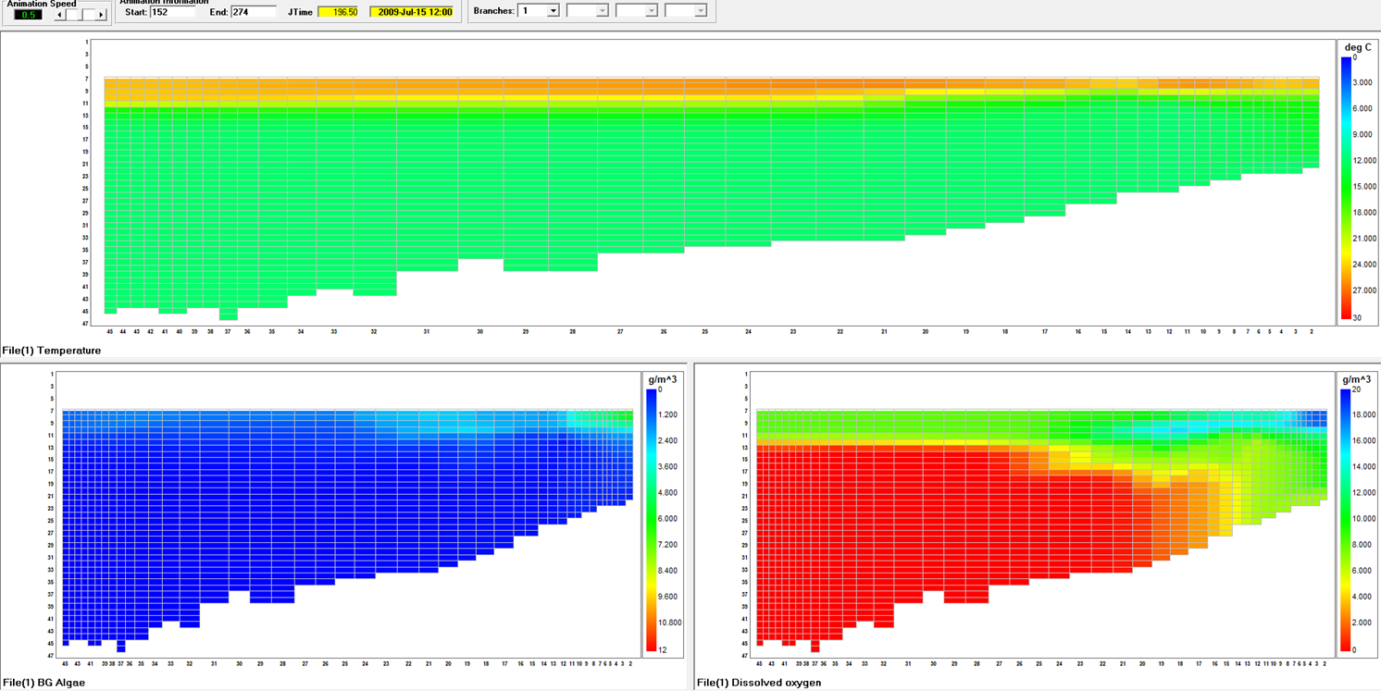
Figure 8. Run A (1 m grid, AVM employed) simulated temperature (top), cyanobacteria (lower left) and dissolved oxygen (lower right). July15th, 12:00 PM.
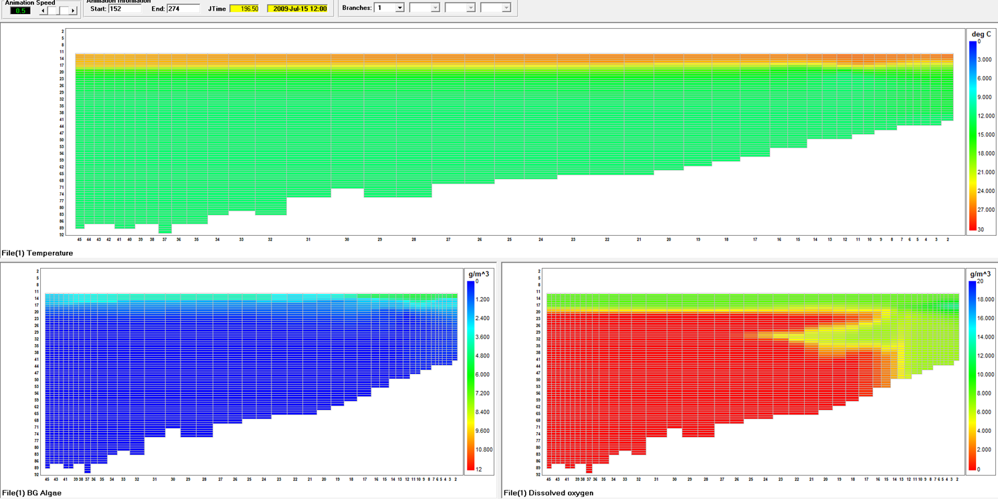
Figure 9. Run B (0.5 m grid, AVM employed) simulated temperature (top), cyanobacteria (lower left) and dissolved oxygen (lower right). July15th, 12:00 PM.
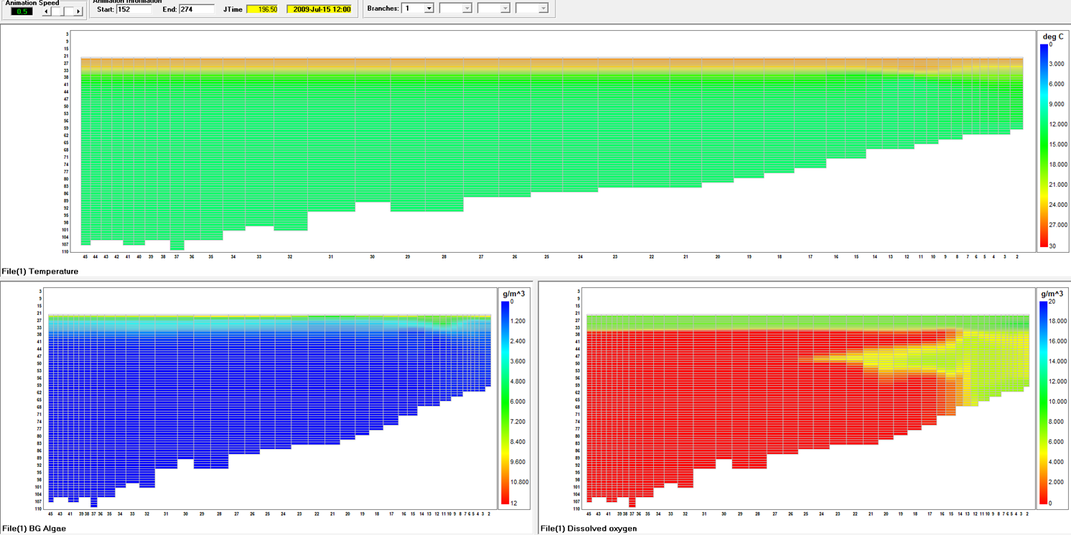
Figure 10. Run C (0.5 m grid with 0.25 m grid in top 9 m, AVM employed) simulated temperature (top), cyanobacteria (lower left) and dissolved oxygen (lower right). July15th, 12:00 PM.
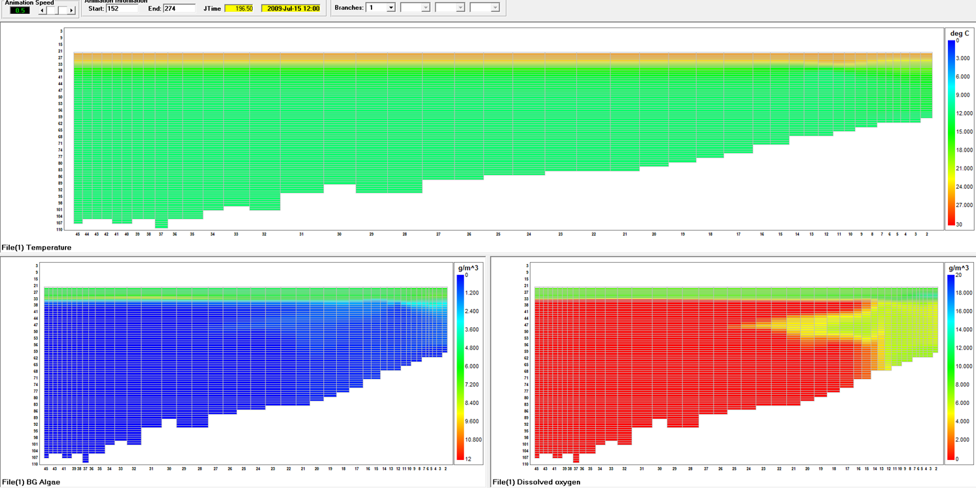
Figure 11. Run D (0.5 m grid with 0.25 m grid in top 9 m, AVM not employed) simulated temperature (top), cyanobacteria (lower left) and dissolved oxygen (lower right). July 15th, 12:00 PM.
Simulated temperature and cyanobacteria profiles of each of the runs at four different locations in the reservoir are presented at six-hour intervals for a representative day (June 15). The four locations are listed below and shown in Figure 12.
- Segment 20
- Segment 31 (the segment where Branch 2 is connected)
- Segment 40
- Segment 58 (the most downstream segment of Branch 2)
The thermal profiles are similar for simulations with a 0.5 or 0.25 m resolution (Runs B, C, and D) throughout the day (Figure 13 through Figure 16). The simulation with the 1 m grid (Run A) is notably warmer and may be a combination of vertical spatial resolution and the amount of cyanobacteria in the near surface waters increasing light extinction.
The cyanobacteria concentration profiles are similar for simulations with a 0.5 or 0.25 m resolution (Runs B, C, and D) throughout the day (Figure 17 through Figure 20). The simulation with the 1 m grid (Run A), as noted above, is notably warmer and the amount of cyanobacteria in the near surface waters is considerably higher than the other simulations.

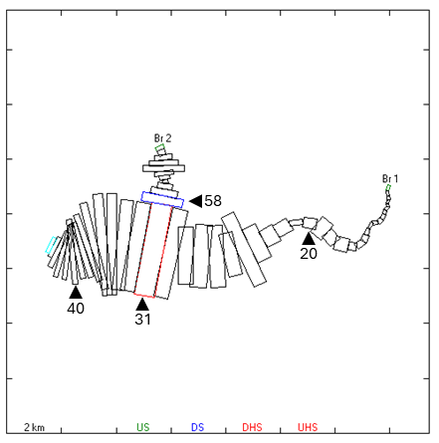
Figure 12. Selected CE-QUAL-W2 segments for model output.

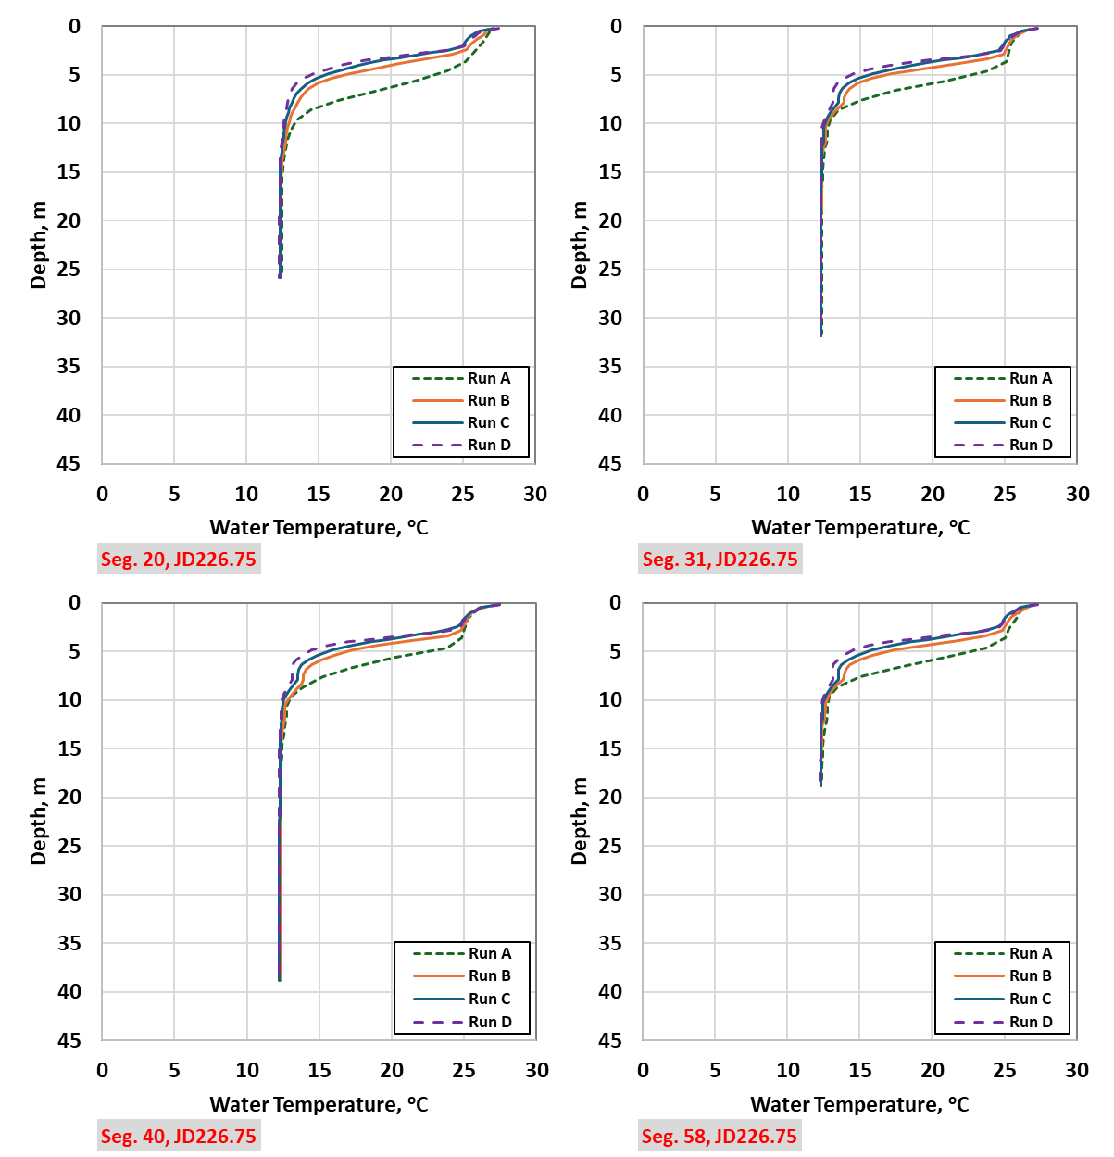

Figure 13. Simulated water temperature profiles at segments 20, 31, 40, and 58. JD 196.00 (July 15th, 00:00).
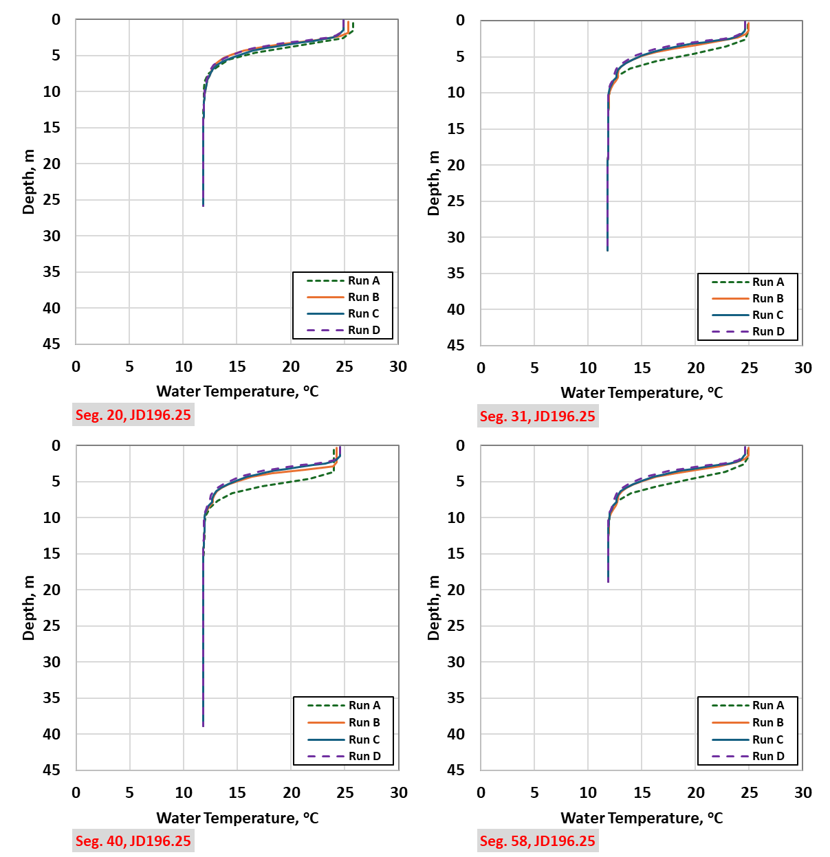

Figure 14. Simulated water temperature profiles at segments 20, 31, 40, and 58. JD 196.00 (July 15th, 06:00).
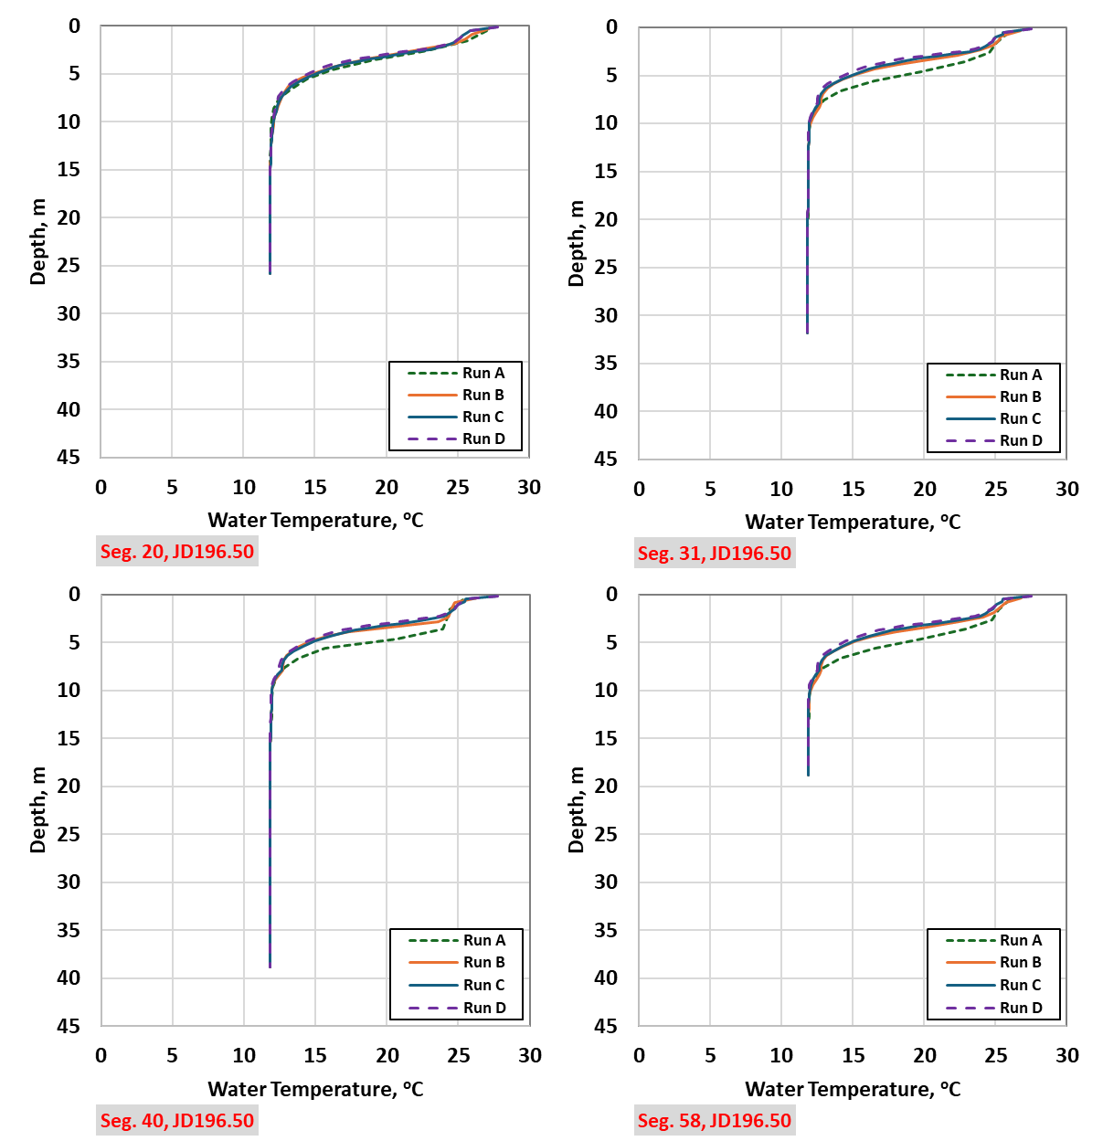

Figure 15. Simulated water temperature profiles at segments 20, 31, 40, and 58. JD 196.00 (July 15th, 12:00).
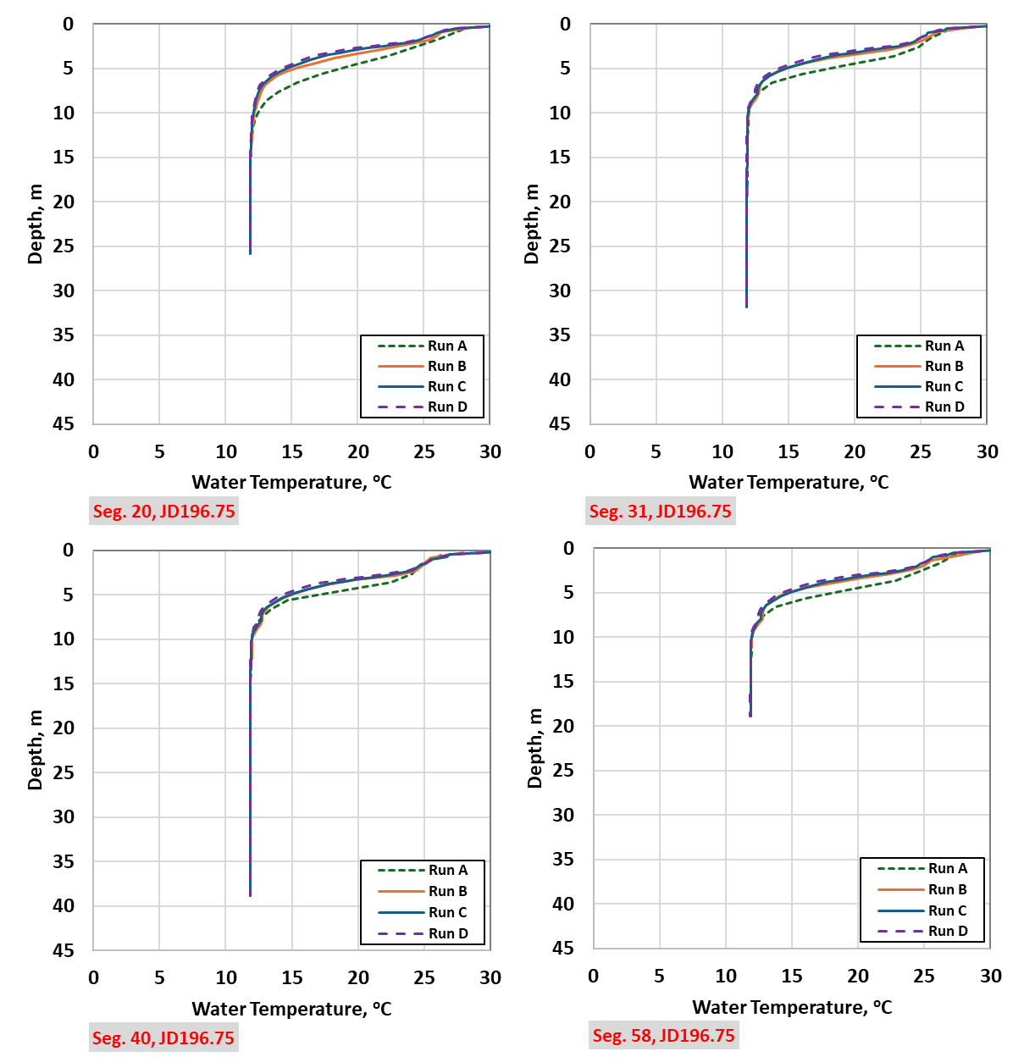
Figure 16. Simulated water temperature profiles at segments 20, 31, 40, and 58. JD 196.00 (July 15th, 18:00).
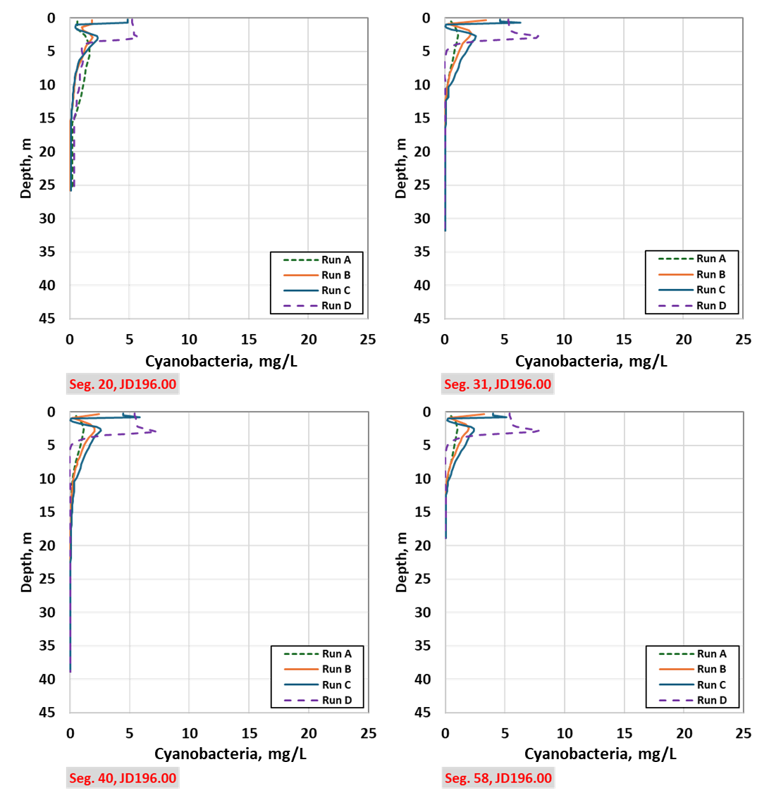

Figure 17. Simulated cyanobacteria concentration profiles at segments 20, 31, 40, and 58. JD 196.00 (July 15th, 00:00).
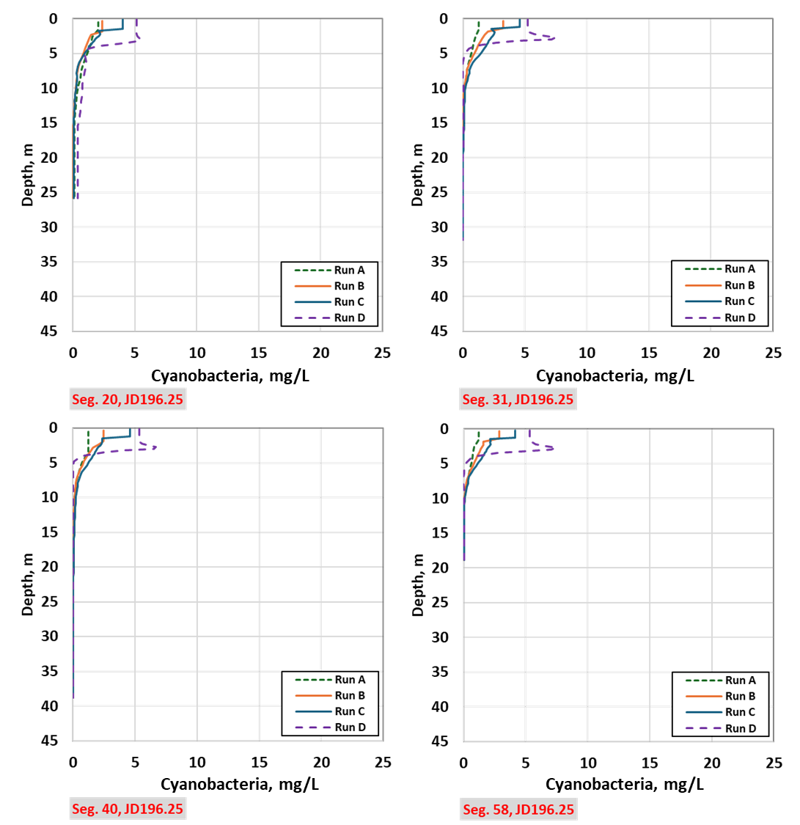

Figure 18. Simulated cyanobacteria concentration profiles at segments 20, 31, 40, and 58. JD 196.00 (July 15th, 06:00).

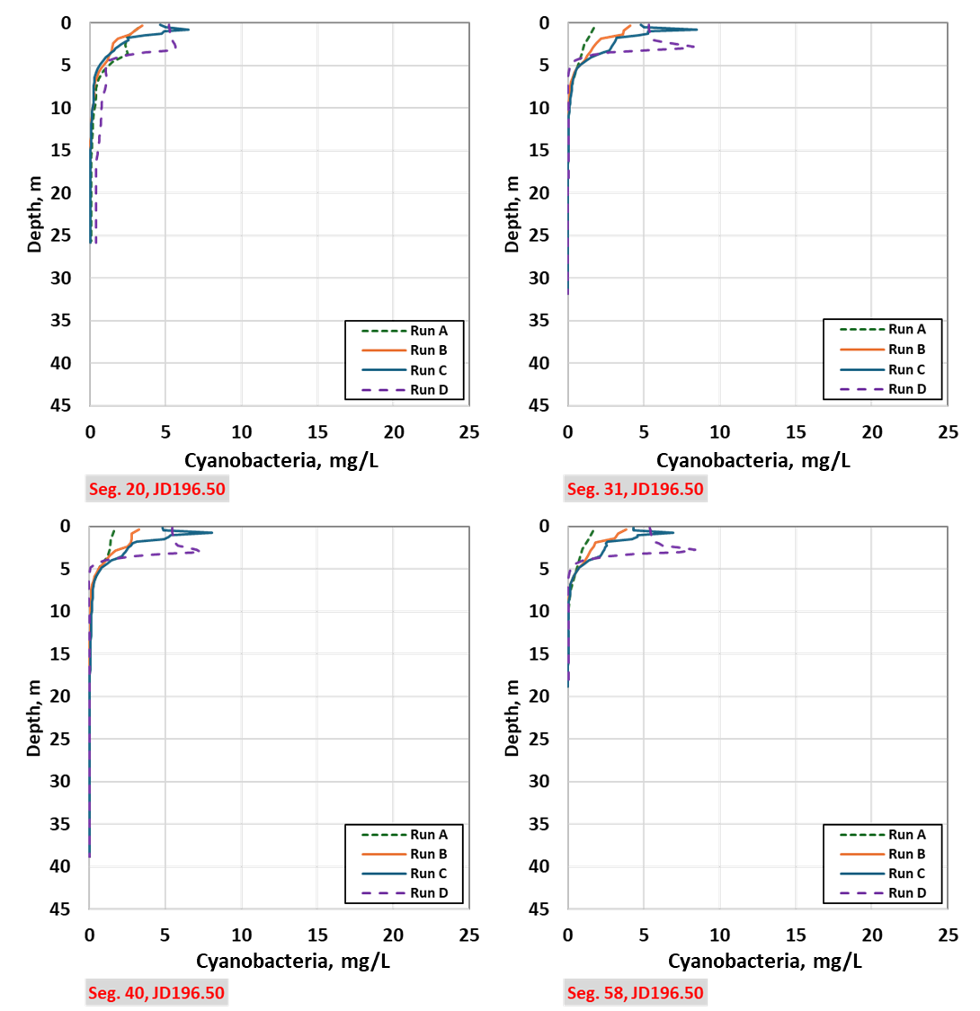

Figure 19. Simulated cyanobacteria concentration profiles at segments 20, 31, 40, and 58. JD 196.00 (July 15th, 12:00).

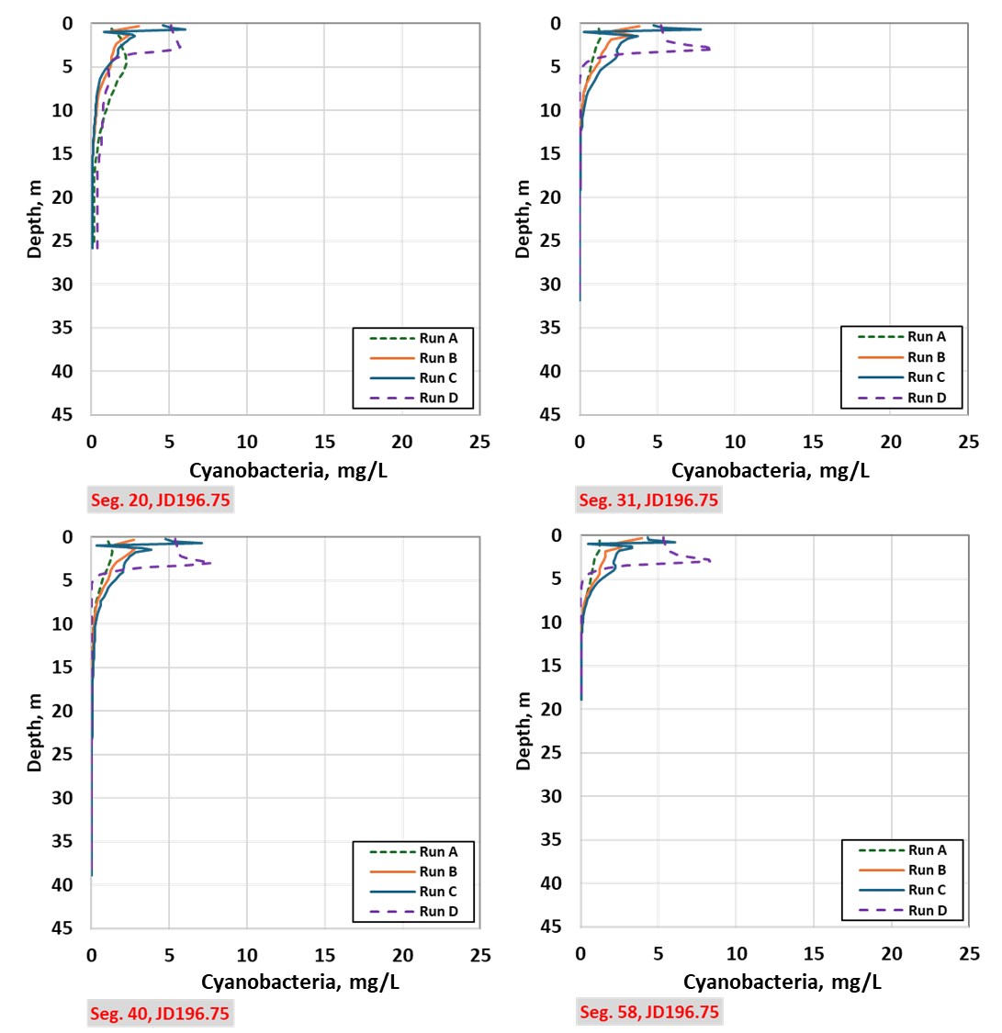

Figure 20. Simulated cyanobacteria concentration profiles at segments 20, 31, 40, and 58. JD 196.00 (July 15th, 18:00).
Comparison of the four runs at mid-day for segment 40 (Figure(a)) indicate:
- Vertical migration logic has an impact on the simulated vertical distribution of cyanobacteria (Run D vs Run A, B, C);
- Grid resolution has an impact on simulated vertical distribution of cyanobacteria. The 1 m grid provides a less detailed vertical distribution of cyanobacteria. The 0.5 m grid yields more differentiation with depth, and the 0.25 m grid provides a notable level of resolution. This outcome suggests that if detailed representation of cyanobacteria is desired a finer grid resolution is required.
Additional insight can be gained by examining a single day at segment 40 every 6-hours over a 24 hour period for the 0.25 m grid (Run C) to track how the vertical migration logic represents the vertical distribution of cyanobacteria.
- While no field data were available to confirm these results, the logic to represent vertical migration allows for a realistic representation of the distribution of buoyancy compensating algae in the near surface waters of the reservoir over the course of a day (Figure(b)).
  - At midnight (solid black line) the vertical distribution appears to reflect the previous day’s distribution with elevated concentrations in the surface waters (6 mg/L), a minimum at approximately 1 m, and a stable deeper concentration ranging from approximately 1 to 3 mg/L below 2 m. This deeper concentration is the same throughout the day.
  - At 6:00 (red line), the vertical distribution exhibits a simpler form with 5 mg/L in the top 1.25 m and a stable deeper concentration below 1.25 m ranging from approximately 1 to 3 mg/L. There is no marked minimum.
  - At 12:00 (blue line), the vertical distribution suggests a response to buoyancy regulation as concentrations increase in shallower waters (8 mg/L at 0.8 m). Below approximately 2 m a stable deeper concentration was present ranging from approximately 1 to 3 mg/L.
  - At 18:00 (green line), the vertical distribution retains the high concentration at 0.8 m, but indicates a minimum of near zero at 1 m. Below approximately 2 m a stable deeper concentration was present ranging from approximately 1 to 3 mg/L.
  - At midnight (next day, represented by the black dashed line), the profile is nearly equivalent to 24 hours earlier.
These findings varied in overall concentration and vertical distribution, but were consistent in progression throughout the 24-hour period for other days in the simulation (i.e., from midnight-to-midnight the progression of a cyanobacteria moving upwards in the water column and returning to a midnight distribution similar to the previous day was common). Some initial observations include:
- The 1 m grid (Run A) does not appear to provide sufficient spatial detail to effectively represent vertical migration. These vertical profiles are less complex and with lower biomass than the 0.5 m (Run B) and 0.25 m (Run C) grids, suggesting that a finer grid may be more effective when modeling vertical migration.
- When the vertical migration logic is not used, the simulations generally distribute cyanobacteria in the top 2 to 4 m without the detail of Runs B and C. Further, the biomass of cyanobacteria is larger in Run D. Thus, simulating cyanobacteria in the model with the vertical migration logic enacted may require a different parameterizing of algal dynamics (e.g., growth rates, mortality rates, etc.) than a simulation where vertical migration is not used.
- The 0.25 m grid (Run C) indicates that CE-QUAL-W2 can provide finer details in thermal stratification and associated cyanobacteria vertical distribution that varies notably over the course of a day.
- The loss function at the bottom of the active zone (for this example set to 0.1 or 10%) can result in a notable loss of standing crop over time. Conservation of mass (biomass) is a consideration when applying the models to ensure they represent the system in questions. Further model testing to assess the impact of this factor as well as other factors (model parameterization, meteorology conditions, grid resolution (including branches), etc.) on simulation results should be completed.
- Simulation results suggest that if buoyancy compensating logic is employed, field data should be collected at appropriate spatial and temporal scales to calibrate model parameters to ensure standing crop is properly represented.

(a) (b)

Figure 21. Simulated cyanobacteria concentration profiles at segment 40 (a) for JD 196.00 (July 15th, 18:00) for Run A,B, C, and D, and (b) for Run C 6/15 0:00, 6:00, 12:00, 18:00 and 6/16 0:00.

In sum, the vertical migration logic in CE-QUAL-W2 appears to provide useful insight into buoyancy compensating cyanobacteria dynamics, particularly with a finer vertical layer height. There is a tradeoff between computational time and grid resolution; however, Run C represents a balance between grid resolution and simulation time by using 0.25 m layer height in shallow waters with an 0.5 m layer height in deeper waters. Detailed spatial and temporal monitoring will be required to calibrate and verify model performance if relying on the model to produce harmful algae blooms for management purposes.
References
Cervarich, A., Overman, C., S.A. Wells and C. Berger. 2020. Dexter Reservoir Model Calibration Updates and Management Scenarios. Prepared for ERDC Contracting Office U.S. Army Corps of Engineers Engi-neer Research and Development Center, Water Quality Research Group, Department of Civil and Environmental Engineering, Portland State University, 109 pp.
Huisman, J., Sharples, J., Stroom, J. M., Visser, P. M., Kardinaal, W. E. A., Verspagen, J. M. and Sommeijer, B. (2004) Changes in turbulent mixing shift competition for light between phytoplankton species. Ecology, 85, 2960–2970.
Kromkamp, J., and A.E. Walsby. 1990. “A computer model of buoyancy and vertical migration in cyano-bacteria.” Journal of Plankton Research, 12(1), 161–183.
Livingstone, D. M. (2003) Impact of secular climate change on the thermal structure of a large temperate central European lake. Clim. Change., 57, 205–225.
Overman, C. 2019. Modeling Vertical Migration of Cyanobacteria and Zooplankton. M.S. Thesis Department of Civil and Environmental Engineering, Portland State University, 233 pp.
Overman, C. and S.A. Wells. 2021. Modeling Cyanobacteria Vertical Migration, J. Environmental Modeling, in-print.

Paerl, H. W. and Huisman, J. (2009) Climate change: a catalyst for global expansion of harmful cyanobacterial blooms. Environ. Microbiol. Rep., 1, 27–37.Wells, S.A. 2023a. A Two-Dimensional, Laterally Averaged, Hydrodynamic and Water Quality Model, Version 4.5 Part 3 Input and Output Files User Manual.
Wells, S.A. 2023b. A Two-Dimensional, Laterally Averaged, Hydrodynamic and Water Quality Model, Version 4.5 User Manual Part 2: Hydrodynamic and Water Quality Model Theory.

Appendix 2 – Building a User Community
The following approach was generated using Google’s Gemini AI Model with the prompt:
Describe how to build an engaged user community for a new environmental simulation model. The community should include model developers and coders as well as model users.

Building an Engaged User Community for an Environmental Simulation Model
Building a thriving community around a new environmental simulation model requires a strategic approach that fosters collaboration, knowledge sharing, and mutual benefit. Here's a roadmap to achieve this:
1. Define Your Community Goals
- Clarify the purpose: Determine the primary objectives of your community. Is it to gather feedback, co-develop the model, or disseminate findings?
- Identify target audience: Determine the specific groups you want to engage (e.g., scientists, policymakers, educators, general public).
2. Choose a Suitable Platform
- Select a platform: Consider factors like ease of use, accessibility, and features when choosing a platform (e.g., forums, social media, dedicated website, or a combination).
- Design user interface: Make the platform intuitive and visually appealing to encourage participation.
3. Foster Open Communication
- Establish communication channels: Provide multiple ways for members to interact (e.g., discussion boards, chat rooms, email).
- Encourage participation: Create a welcoming environment where everyone feels valued and respected.
- Provide clear guidelines: Set expectations for behavior and content to maintain a productive community.

4. Offer Valuable Content
- Share model information: Provide clear documentation, tutorials, and examples of model usage.
- Create educational resources: Offer webinars, workshops, or online courses to enhance user knowledge.
- Showcase success stories: Highlight how the model is being used to address environmental challenges.
5. Facilitate Collaboration
- Organize collaborative projects: Encourage members to work together on specific projects or challenges.
- Promote knowledge sharing: Create opportunities for members to share their expertise and learn from others.
- Establish mentorship programs: Pair experienced users with newcomers to facilitate knowledge transfer.
6. Provide Incentives and Recognition
- Offer rewards: Recognize contributions through badges, points, or other incentives.
- Highlight community members: Showcase outstanding contributions to inspire others.
- Provide exclusive access: Offer early access to new model features or data for active community members.
7. Gather and Act on Feedback
- Conduct surveys: Regularly assess community needs and satisfaction.
- Implement suggestions: Incorporate user feedback into model development and community management.
- Show appreciation: Demonstrate that you value community input.

8. Leverage Social Media
- Create engaging content: Share updates, news, and interesting findings on social media platforms.
- Use relevant hashtags: Increase visibility and reach a wider audience.
- Encourage sharing: Make it easy for members to share content with their networks.
9. Build Partnerships
- Collaborate with other organizations: Partner with complementary organizations to expand your reach.
- Engage with influencers: Collaborate with influential individuals in the environmental field.
10. Measure and Evaluate
- Track community growth: Monitor membership numbers and engagement metrics.
- Assess impact: Evaluate the community's contribution to model development and usage.
- Make adjustments: Continuously refine your community strategy based on data and feedback.
Additional Tips:
- Personalize the experience: Make members feel valued and connected.
- Build trust: Be transparent and honest in your communication.
- Celebrate successes: Recognize and share the community's achievements.
- Be patient: Building a strong community takes time and effort.
By following these guidelines, you can create a vibrant and engaged community that supports the development and use of your environmental simulation model, ultimately leading to greater impact.

